**Final Gantt Chart (after Pivot)**

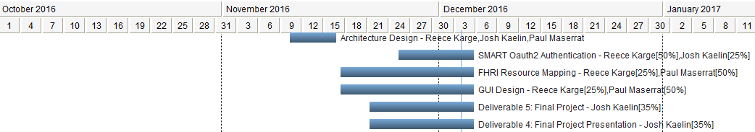

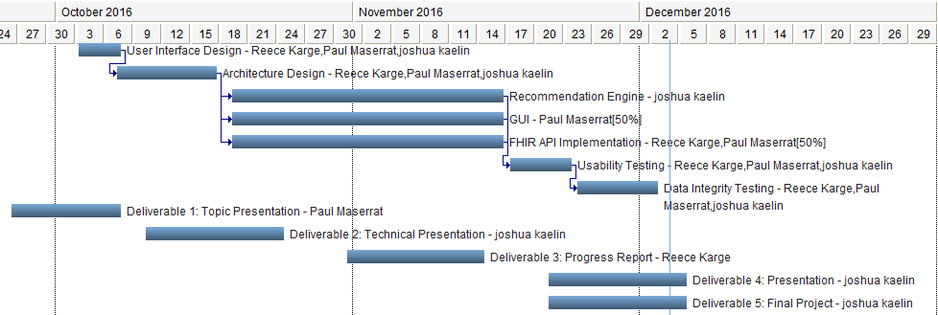

**Initial Gantt Chart (projection)**

